IDEATION PHASE
LITERATURE SURVEY
DATE 03 September 2022
TEAM ID PNT2022TMID28577
PROJECT NAME Predicting the energy output of wind turbine based on weather condition

Literature Survey:

S.NO TITLE AUTHOR YEAR PROPOSED SYSTEM
- A Multi-Step Heifeng 2021 A Multi-step wind power prediction Prediction luo, Xun method was proposed by exploiting
Method for Wind dou, Rong improved TCN to correct the
Power Based on sun cumulative error. First, multi-scale
Improved TCN convolution (MSC) and selfto Correct attentiveness (SA) were adopted to Cumulative Error optimize the problem that a single-
scale convolution kernel of TCN is difficult to extract temporal and spatial features at different scales of the input sequence.
- Remotely Mark A. 2019 Remotely sensed surface winds Sensed Winds Bourassa, (scalar winds and vector winds) and Wind Thomas with related material on surface
Stresses for Meissner, stress, air-sea heat fluxes, currents,
Ivana
Marine Cerovecki sea state, and precipitation.
Forecasting and
Ocean Modeling
- Wind Muhammad 2020 Wind forecasting methods and Generation Shahzad the artificial neural network, The
Forecasting Nazir, instrument used to measure wind
Methods and Fahad assimilation is analyzed and
Alturise,
Proliferation of Sami discussed, accurately. The high
Artificial Neural Alshmrany forecasting accuracy could be
Network achieved through proper handling
and calibration of the wind-
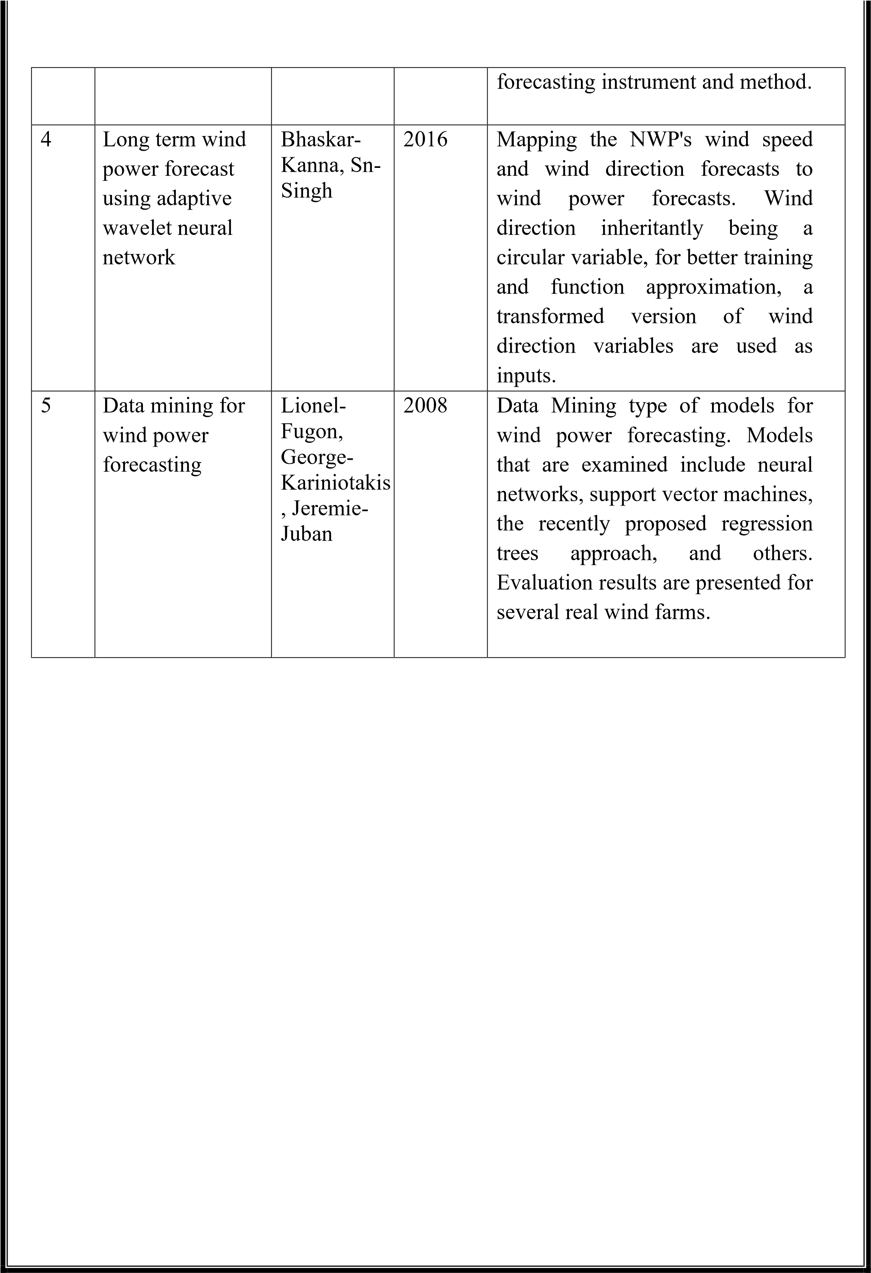

REFERENCES:
- Luo H, Dou X, Sun R and Wu S (2021) A Multi-Step Prediction Method for Wind Power Based on Improved TCN to Correct Cumulative Error. Front. Energy Res. 9:723319. doi: 10.3389/fenrg.2021.723319.
- Bourassa MA, Meissner T, Cerovecki I, Chang PS, Dong X, De Chiara G, Donlon C, Dukhovskoy DS, Elya J, Fore A, Fewings MR, Foster RC, Gille ST, Haus BK, Hristova-Veleva S, Holbach HM, Jelenak Z, Knaff JA, Kranz SA, Manaster A, Mazloff M, Mears C, Mouche A, Portabella M, Reul N, Ricciardulli L, Rodriguez E, Sampson C, Solis D, Stoffelen A, Stukel MR, Stiles B, Weissman D and Wentz F (2019) Remotely Sensed Winds and Wind Stresses for Marine Forecasting and Ocean Modeling. Front. Mar. Sci. 6:443. doi: 10.3389/fmars.2019.00443.
- Nazir, Muhammad Shahzad, Fahad Alturise, Sami Alshmrany, Hafiz. M. J Nazir, Muhammad Bilal, Ahmad N. Abdalla, P. Sanjeevikumar, and Ziad M. Ali. 2020. "Wind Generation Forecasting Methods and Proliferation of Artificial Neural Network: A Review of Five Years Research Trend" Sustainability 12, no. 9: 3778. https://doi.org/10.3390/su12093778.
- Bhaskar-Kanna, Sn-Singh, Long term wind power forecast using adaptive wavelet neural network(2016), doi.org/10.1109/UPCON.2016.7894735.
- Lionel-Fugon, George-Kariniotakis, Jeremie-Juban, Data mining and wind power prediction(2008), Accepted 1 February 2012, Available online 29 March 2012. https://doi.org/10.1016/j.renene.2012.02.015.

